**Step 1 – angular project**

Create a new angular project with the following commands:

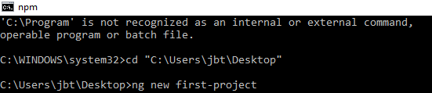

When the project is created successfully, you will see the following cli:

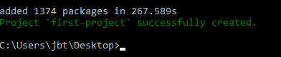

Now, build the project, with the following command:

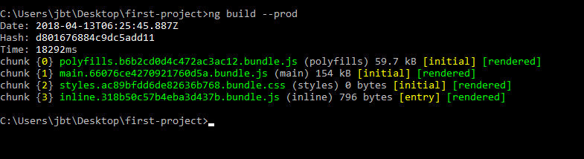

And you will get the "dist" directory:

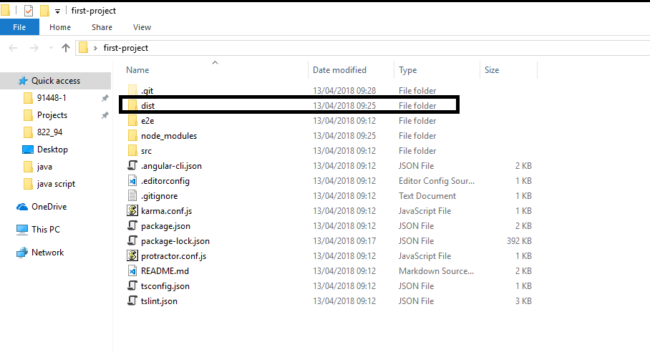

**Step 2 – node project**

Create a new folder for the node project, and change the cli path to this folder:

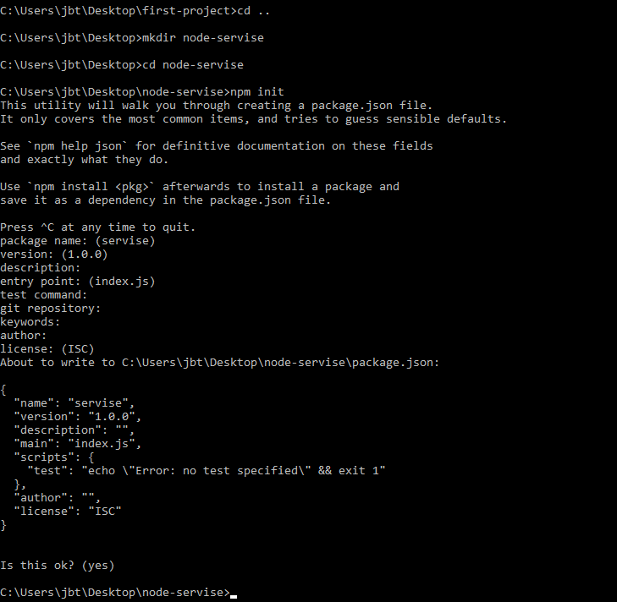

Add a "package.json" file, to the project folder, with the following command:



Next, install the "express" package, through the cli:

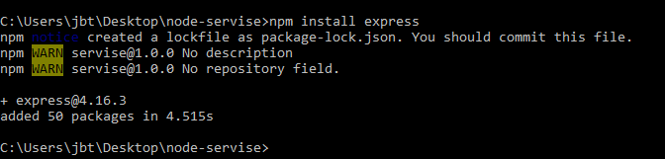

And open the project in visual studio code:

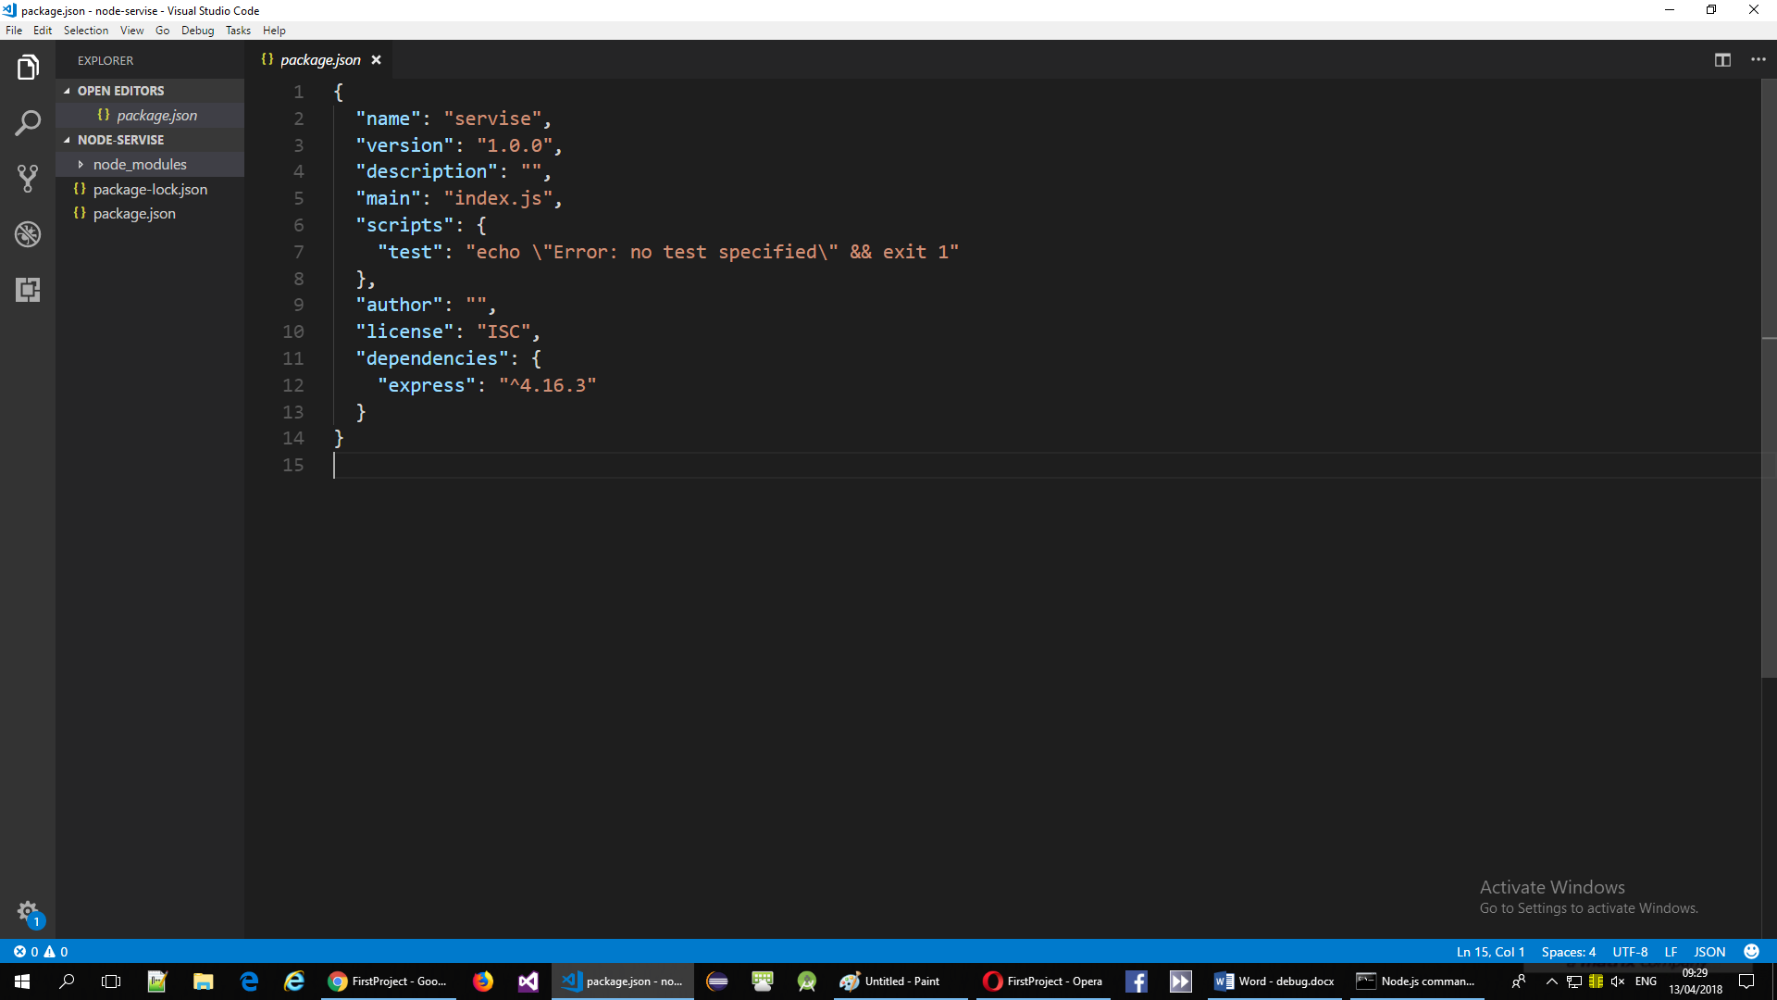

Open the project's folder:

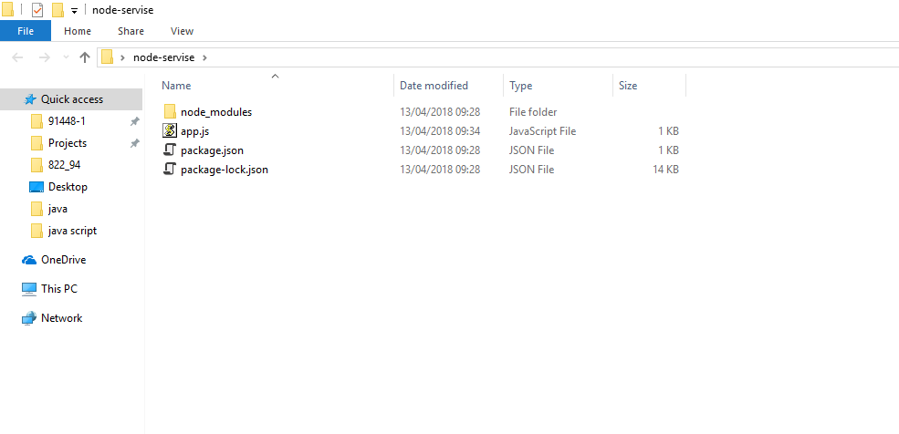

Now, go to the angular folder that we created at step 1, and copy the "dist" folder that contains the production version of the angular project:



Paste the folder into the node project's folder:

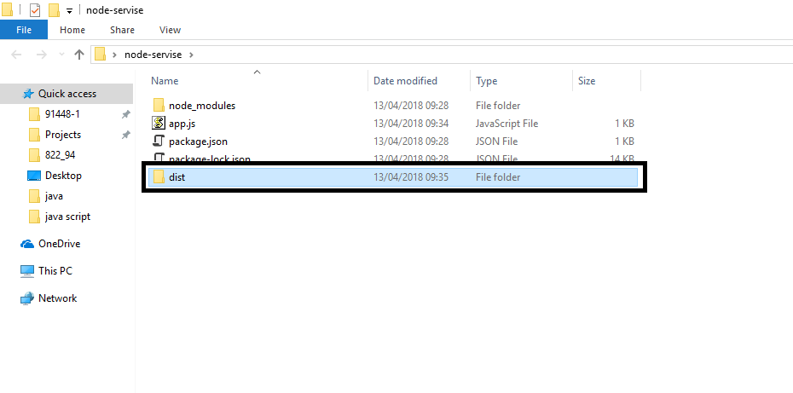

Check your local node version, and add it to the "package.config" file:

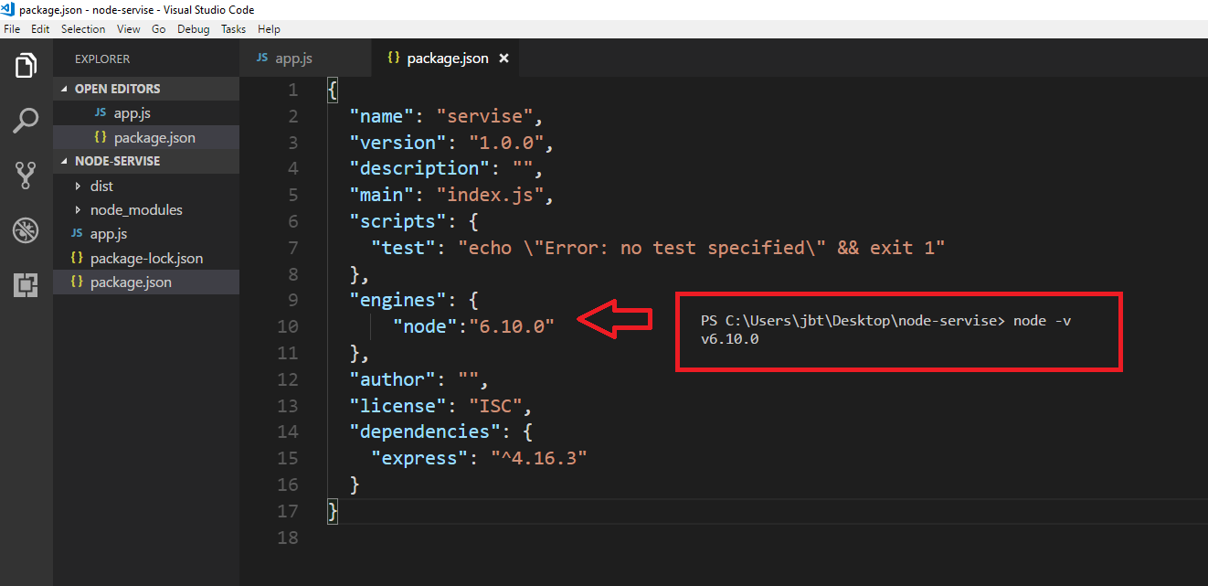

Add a new file, named "app.js", and paste into it the following code:

const express= require ('express');

const app=express();

app.use(express.static('./dist'));

let port=process.env.PORT||3500;

app.listen(port,()=>{console.log(`server listening on port ${port}`)});

now, you can simply run the application with the following command:

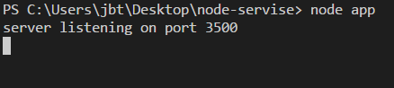

Open " <http://localhost:3500/>" in the browser:

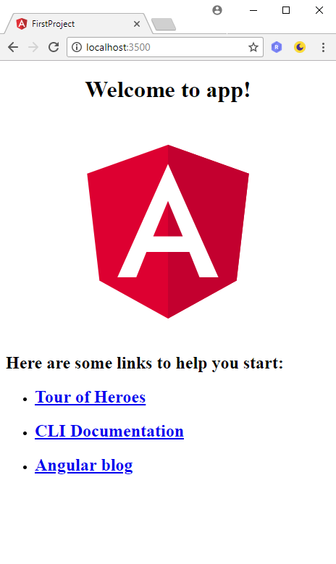

Add the "node app" running command to the "package.json" file, as shown in the following screenshot:

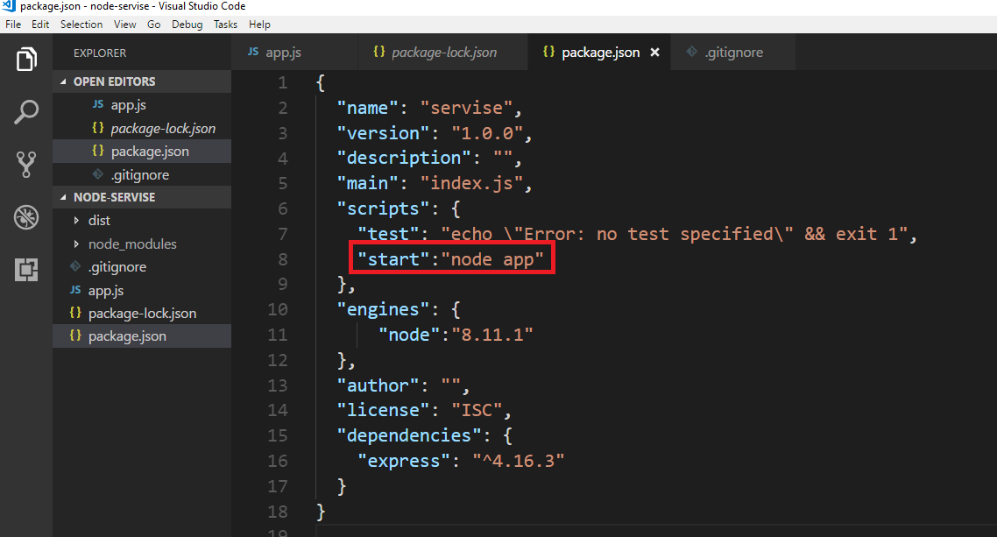

now, try to run the application with the "npm start" command, if you get the following output, your configuration are done successfully:

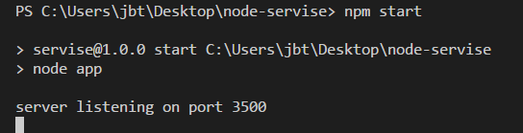

**Step 3 – git & node-project**

Check in the cli that you have git installed in your machine:



Add your node project to the git:

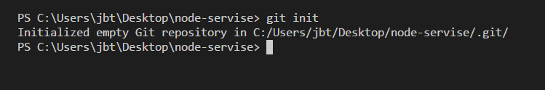

Check that you have a new "git" folder in the project:

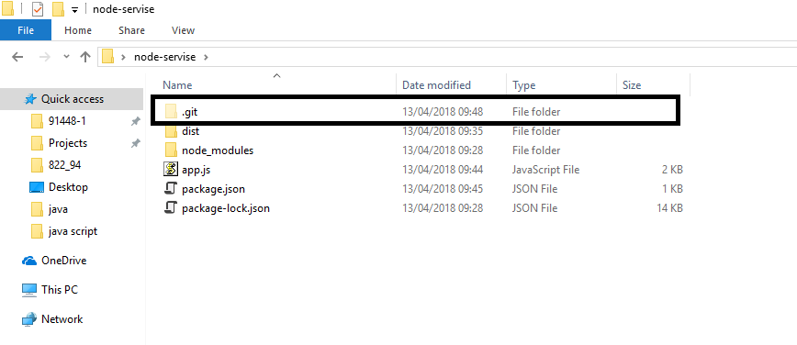

Now, add to the node project a ".gitignore" folder, to ignore all the npm packages:

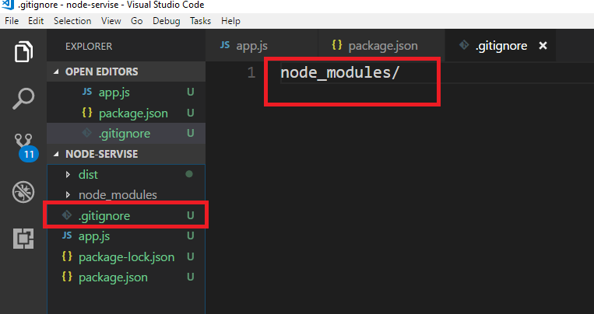

And commit all the content:

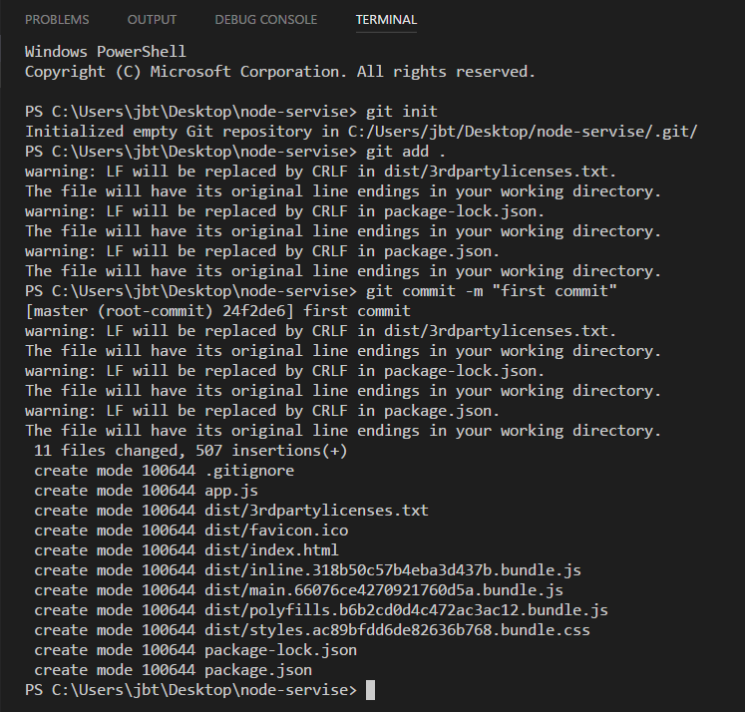

**Step 4 – heroku & node-project**

Install heroku-cli globally on your machine:

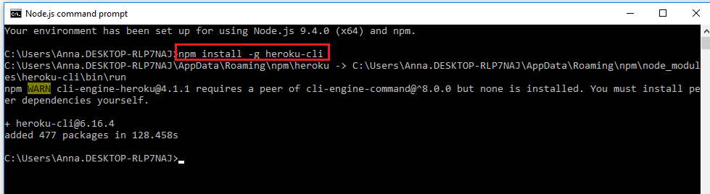

To confirm the installation check the version:

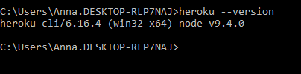

Open an account in heroku:

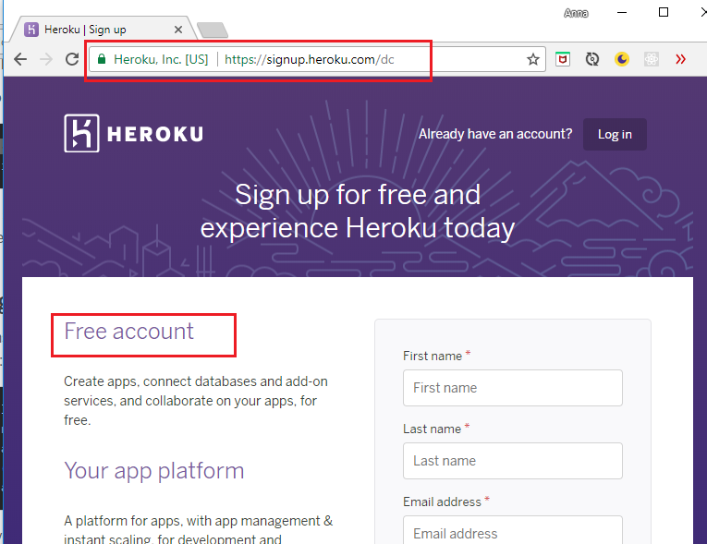

Upload the node project to heroku, with the following commands:

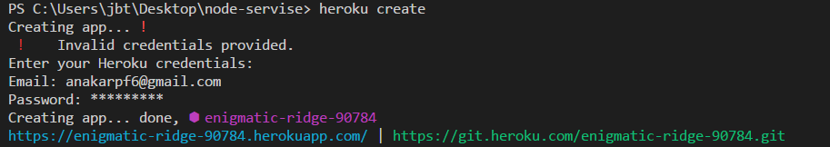



At the end, you will get the link of your new site:

